# Acceptation

In this document, the user will be guided through the application. Each feature will be visited and the desired outcome is described. If the user is able to complete each step without any errors occurring, the app is considered a success.

We assume that the user has a basic knowledge of working with smartphones. We also assume that the user knows what the *scrum* way of project management and *scrum* related terminology are.

We also assume the user has the Scrummer Companion app already installed on his smartphone. Also the user should have internet connectivity on its phone.

The test user should also take note that any changes can take up to one minute to process to the server. If the user considers this and every test turns out positive the test is succesfull.

## Login

These are the steps required to test the login part of the application:

1. Start the application (*Scrummer Companion*) by opening it on your phone. Press the login button.

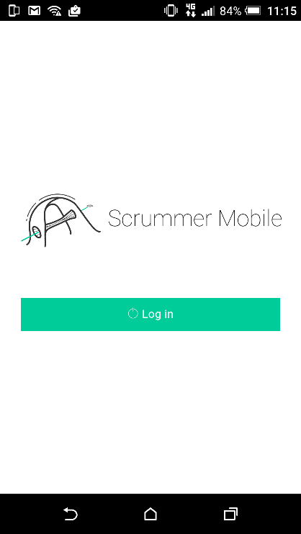

1. You will now enter the login screen. It should look like this:

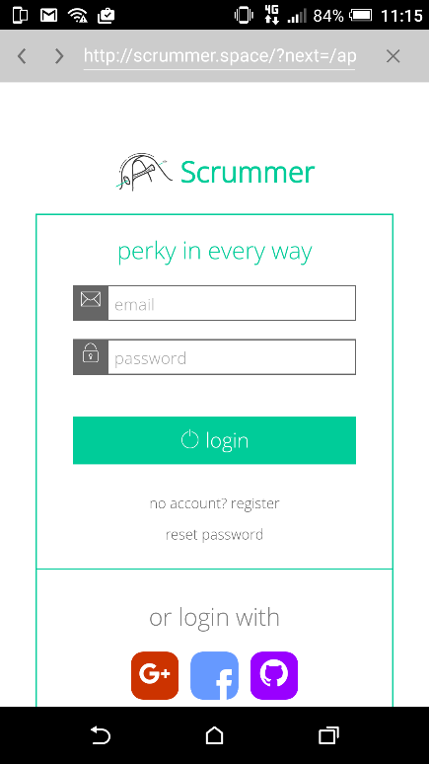

If your screen looks the same, go on and fill in the login credentials. Both email and password are case-sensitive.

Email: [bennevos@gmail.com](mailto:bennevos@gmail.com)

Password: Potato90

1. Press the login button to login to the application
2. You should now be redirected to the application. If you get an error, make sure the login information is filled in correctly and you are connected to the internet.

If you do not get redirected to the page, contact the developers to see what went wrong and how we can solve it.

If everything is the same as described in the steps above, the login feature works correctly. Please fill in any feedback below.

This area is for user remarks

## Navigation

The application switches between the tabs by swiping to left and right on the screen or by pressing the buttons / tabs displayed on the bottom of the screen. The buttons on the bottom all represent a different page (cards / perks / profile).

1. Swipe from left to right. If the screen switches tabs this feature is working correctly. Also notice how the buttons in the bottom change color.
2. Now try to switch tabs by pressing the buttons on the bottom of the screen. If the application switches tabs with this as well this feature is also working correctly

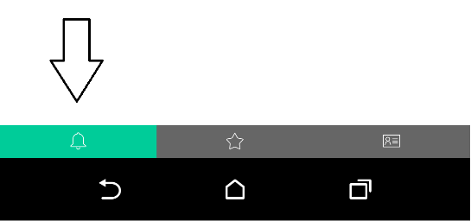

Did everything work correctly? If not, please contact the developers. If you have any feedback please fill it in below.

This area is for user remarks

## Profile widget

The profile widget should show all your current power points. If it does not, contact the developer. In case it does follow the steps below:

1. On the right top in the profile widget you will see a minus icon. Press the icon, the profile widget should collapse now.



1. After you did this, press the plus icon in the top right. The profile widget should expand again now.



1. If all above items work correctly the general features of the application are working correctly.

In case any of the steps is not working correctly, please contact the developers. If you have any feedback you can fill it in below.

This area is for user remarks

## Card overview

This step requires a few things from the desktop application. To test this step, we need to have an active card that someone else assigned to us. It will show up in the mobile application once the owner of the card sets it to “verify”-status.

1. Make sure you followed the above step correctly.
2. Open the card overview. (Left tab, with a bell symbol.)
3. Is the card displaying like one of the following images? It is also possible that the card does not have a status yet. If it does, proceed to the next step.

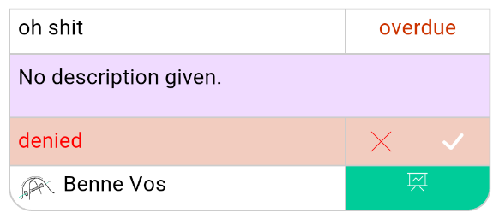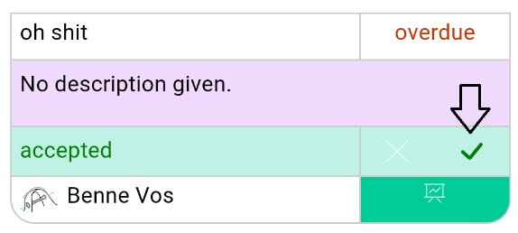

1. Step 5 and 6 can be done in reverse order. This might be necessary if there are no cards that are without status or with “denied”-status.
2. First press the checkmark displayed on the card. If the checkmark turns green this step works correctly and is completed.

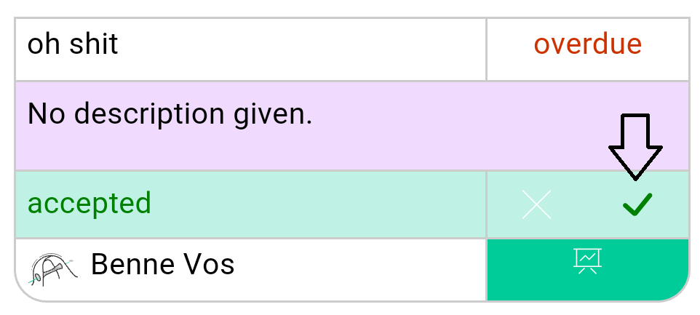

1. Next press the cross icon on the card. If the cross turns red this step works correctly and is completed.

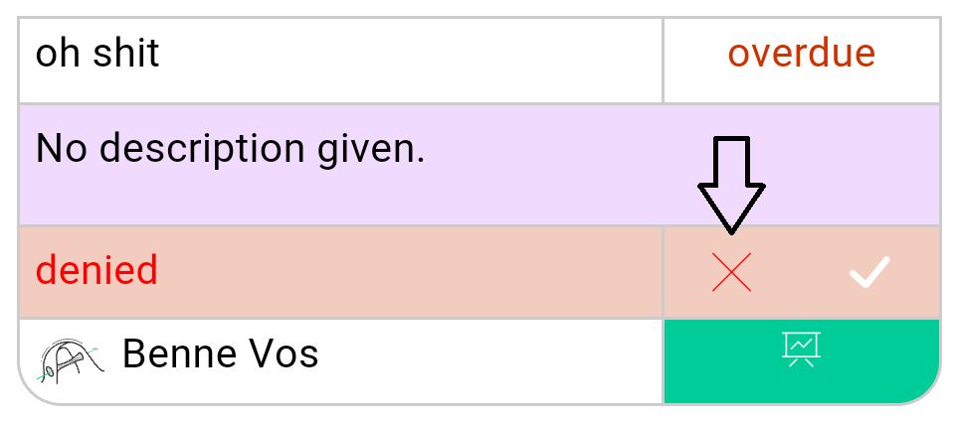

1. If all the above steps work correctly the card overview is working correctly.

Did everything work like described in the steps? If not, please contact the developer. You can fill in your feedback about the cards page in the area below.

This area is for user remarks

## Perks

To test the perks part of the application you need at least one power point in one of the 5 powers. This is needed to activate one of the perks.

1. Open the perks page. (Centre tab, with a star symbol.)
2. Press on the first perk or the power which you’d like to buy, like described above.

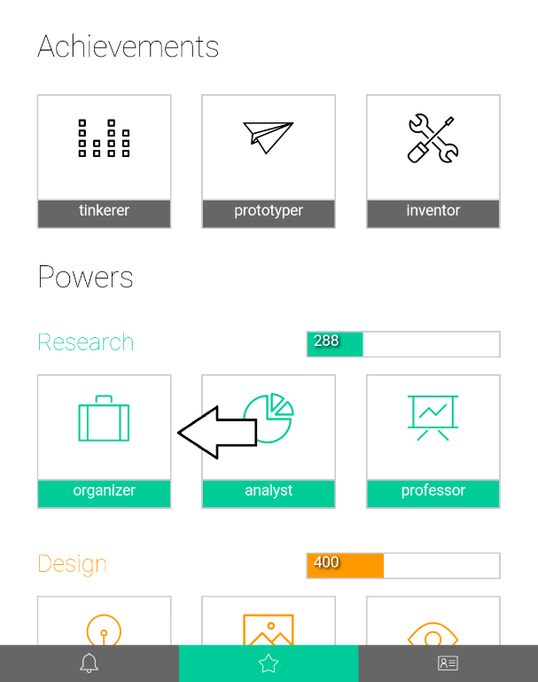

1. Press the buy button.

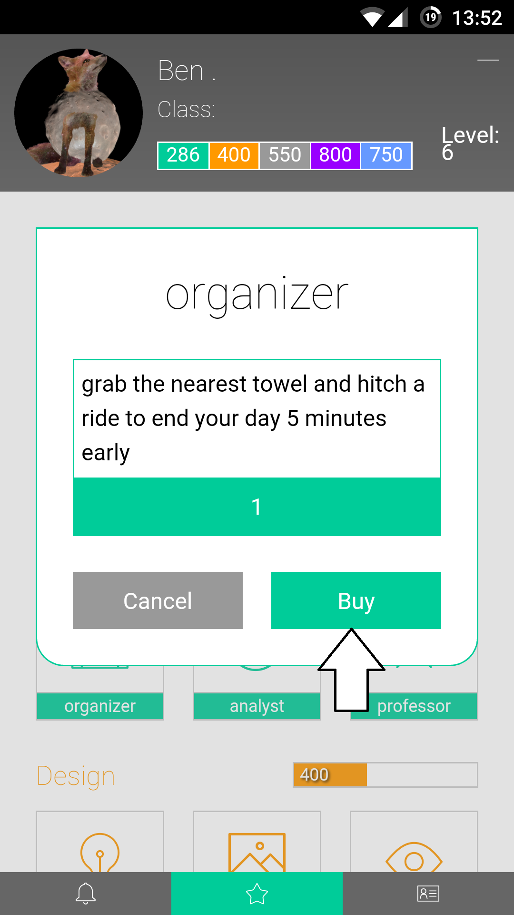

1. Sometimes a power is not available for purchase. The information window should indicate this. This can be due to many reason, of which the most common is that your don’t have enough power points left.

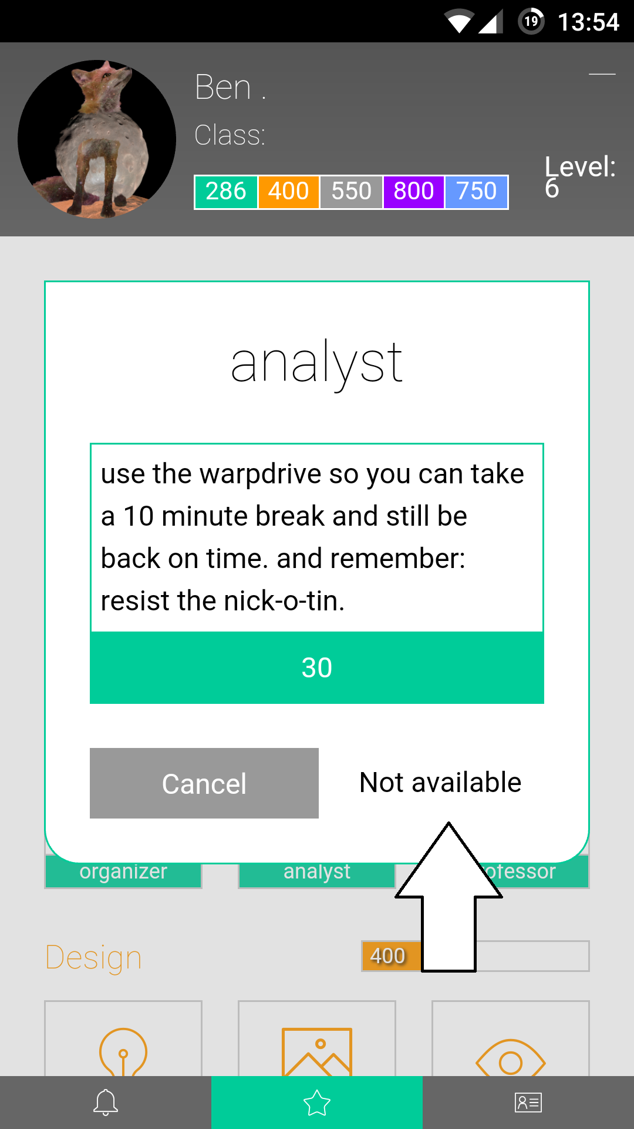

1. If you don’t see any errors and see a timer on the perks you just bought this feature works correctly and has been tested.

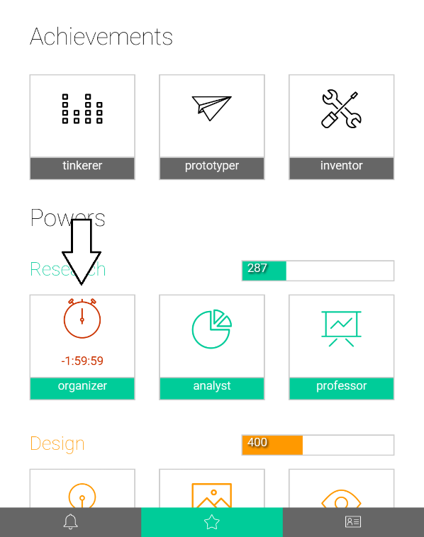

Did everything work like described in the steps above? If not, please contact the developer. Let us know if you have any feedback in the area below.

This area is for user remarks

## Profile overview

1. Open the profile overview tab. (Most right tab, with a profile card symbol)
2. If your experience and power points are displaying correctly this page works. You can verify this at your own profile page on the *Scrummer* website. It might take up to 5 minutes to synchronize the app.

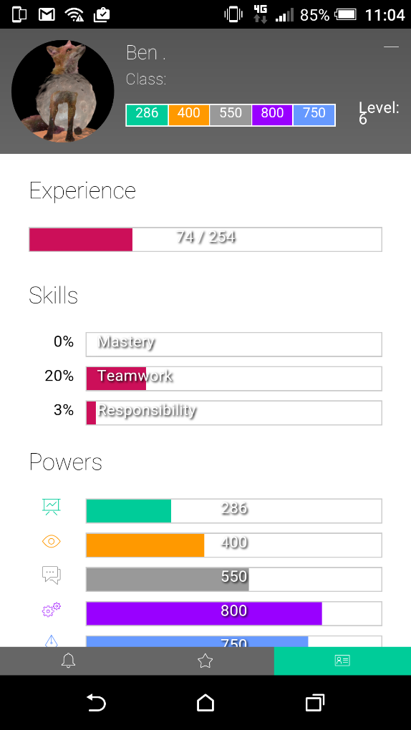

1. Scroll all the way down.
2. Press the logout button to logout of the application.

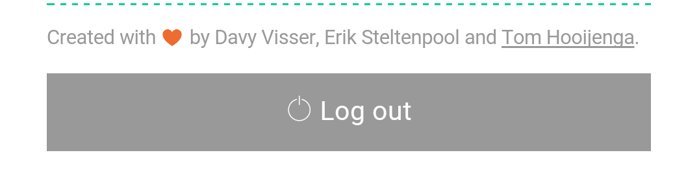

1. You should now see the login page.

If everything works according to the steps above the profile page of the application also works correctly. If this is not the case please contact the developer. You can fill in any feedback in the area below.

This area is for user remarks